1. **Write a program to count the occurrences of a character in the given string.**

.model small

.data

input db "How would it work?$"

o db "o"

n db 0

.code

main proc near

mov ax,@data

mov ds,ax

mov es,dx

lea si,input

mov bl,o

mov ah,"$"

l1:

mov al,[si]

cmp al,bl

je l2

cmp al,ah

je over

inc si

jmp l1

l2: inc n

inc si

jmp l1

over:

mov ax,04ch

int 21h

endp

end

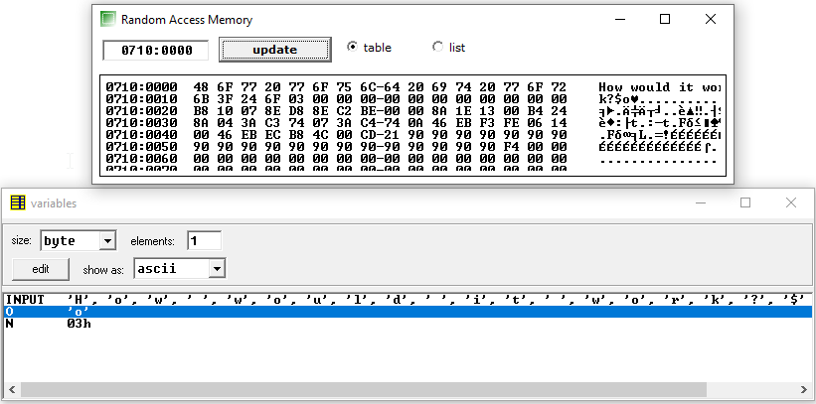

1. **Write a program to count the occurrences of a substring in the given string.**

.model small

.data

str db "aba$"

input db "ababababababababa$"

len db ?

N db ?

.code

main proc near

mov ax,@data

mov ds,ax

mov es,ax

mov ax,0000h

mov al,'$'

lea di,str

repnz scasb

mov bx,di

mov len,bl

dec len

mov dl,len

mov dh,00h

lea si,input

lea di,str

mov ah,"$"

l1:

cld

lodsb

mov bl,[di]

cmp al,bl

je l2

lea di,str

mov dl,len

cmp al,ah

je over

jmp l1

l2:

inc di

dec dl

cmp dl,dh

je l3

jmp l1

l3:

lea di,str

mov dl,len

inc N

jmp l1

over:

mov ax,04ch

int 21h

endp

end

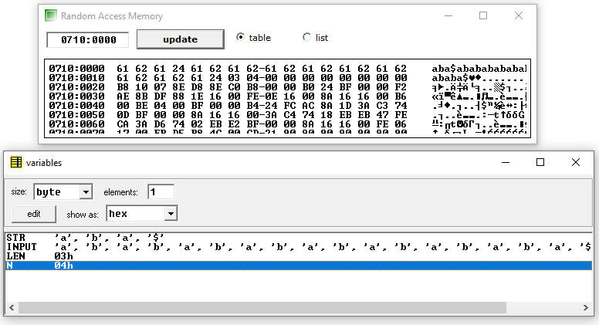

1. **Write a program to copy a string pattern n number of times.**

.model small

.data

str db "%#@$"

output db 50 dup(?)

len db ?

N db 3

.code

main proc near

mov ax,@data

mov ds,ax

mov es,ax

mov ax,0000h

mov al,'$'

lea di,str

repnz scasb

mov bx,di

mov len,bl

mov al,len

mov bl,N

mul bl

mov cx,ax

lea di,output

lea si,str

l1:

movsb

loop l1

mov ax,04ch

int 21h

endp

end

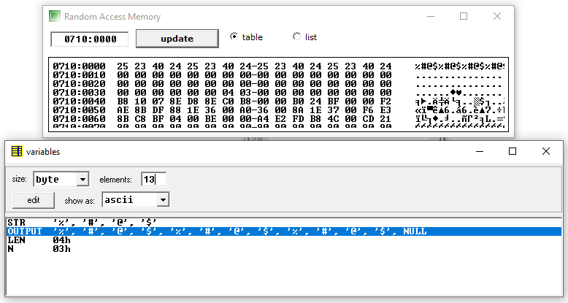

1. **Write a program to find the first occurrence of a character in the given string.**

.model small

.data

str db "!@#%^&*abcsd$"

O db "c"

len db ?

First dw ?

.code

main proc near

mov ax,@data

mov ds,ax

mov es,ax

mov ax,0000h

mov al,'$'

lea di,str

repnz scasb

mov bx,di

mov len,bl

lea si,str

mov cl,len

l1:

cld

lodsb

cmp al,O

je over

loop l1:

over:

mov First,si

mov ax,04ch

int 21h

endp

end

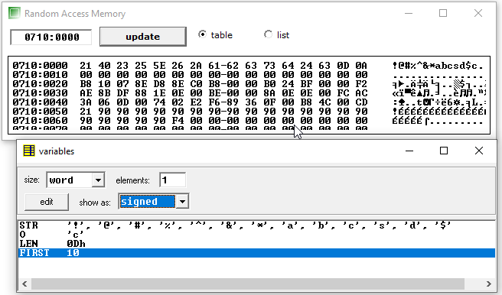

1. **Write a program to find the last occurrence of a character in the given string.**

.model small

.data

str db "abcbcabacdsgd$"

f db "c"

len dw ?

Last dw ?

.code

main proc near

mov ax,@data

mov ds,ax

mov es,ax

mov ax,0000h

mov al,'$'

lea di,str

repnz scasb

mov bx,di

mov len,bx

mov bx,0000h

lea bx,str

add bx,len

mov si,bx

dec si

mov cx,len

l1:

std

lodsb

mov bl,f

cmp al,bl

je over

loop l1

over:

inc si

inc si

mov Last,si

mov ax,04ch

int 21h

endp

end

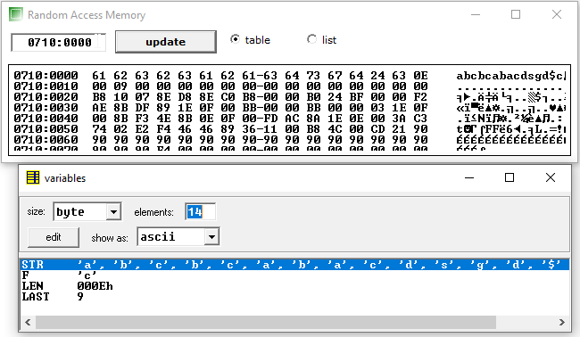

1. **Write a program to remove a single character from the given string**.

.model small

.data

str db "abcbcabacdsgd$"

r db "c"

new db 40 dup(?)

len dw ?

.code

main proc near

mov ax,@data

mov ds,ax

mov es,ax

mov ax,0000h

mov al,'$'

lea di,str

repnz scasb

mov bx,di

mov len,bx

lea di,new

lea si,str

mov cx,len

l1:

lodsb

cmp al,r

je l2:

stosb

l2:

loop l1

mov ax,04ch

int 21h

endp

end

